DEVOPS with MULTI-CLOUD
Practice Tasks

Institute Name : V Cube software solutions
Course : DevOps with Multi-Cloud
Batch : 30
Trainer : Krishna reddy sir

Prepared by : Saikiran Lonka
(MCD-AZ30-030)

TASK-3 : VNet Peering.
Date : 23/01/26

Objective :-
The objective of this task is to configure VNet peering between two Azure virtual networks.This enables secure and private communication between resources in different VNets.It helps improve network connectivity without using the public internet.

VNet Peering :-
Azure VNet Peering is a feature that connects two virtual networks in Azure, allowing resources in both networks to communicate privately using Azure’s internal network.
It provides low-latency, secure connectivity without using the public internet or gateways.

Types of Azure VNet Peering:
- Regional VNet Peering :-
  - Connects virtual networks in the same Azure region.
  - Uses Azure’s private network for fast and secure communication.
  - Commonly used when resources are located in one region.

→ To implement the Regional Vnet peering, created two Virtual Networks VN01 and VN02 in the same region.
  - Now to establish the peering connection between the two Vnets we need to peering to the Vnet 1 & 2.
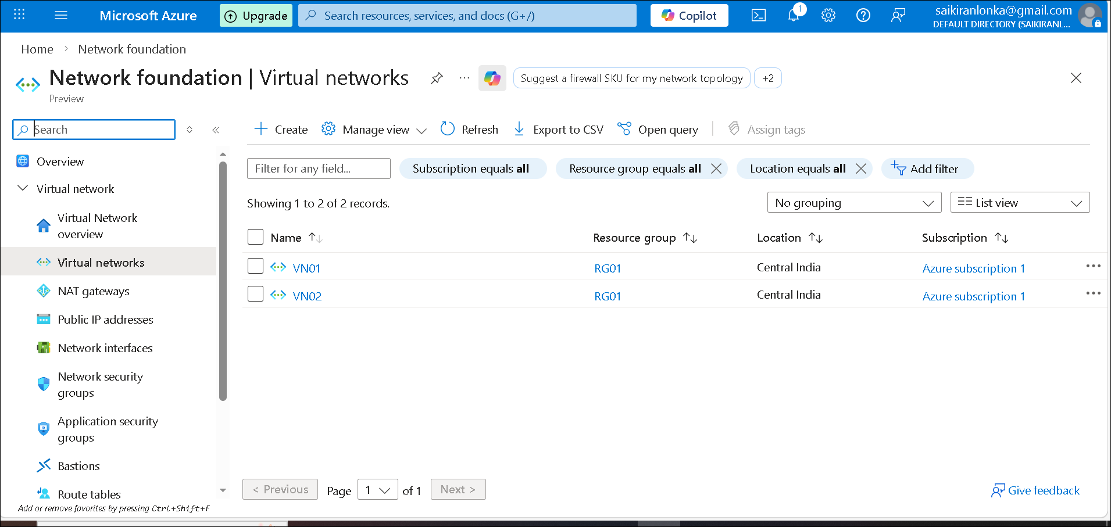
fig(1) Created two Virtual Networks.

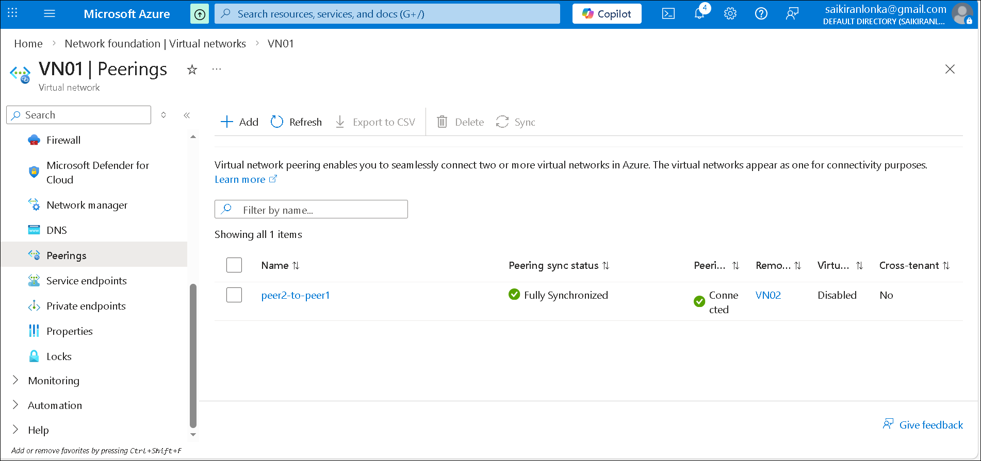

fig(2) Successfully added Peering to Vnets.

  - Now to connect the two Vnets, log in to the Virtual Machine with their public ip address. And use the Ping command to connect.
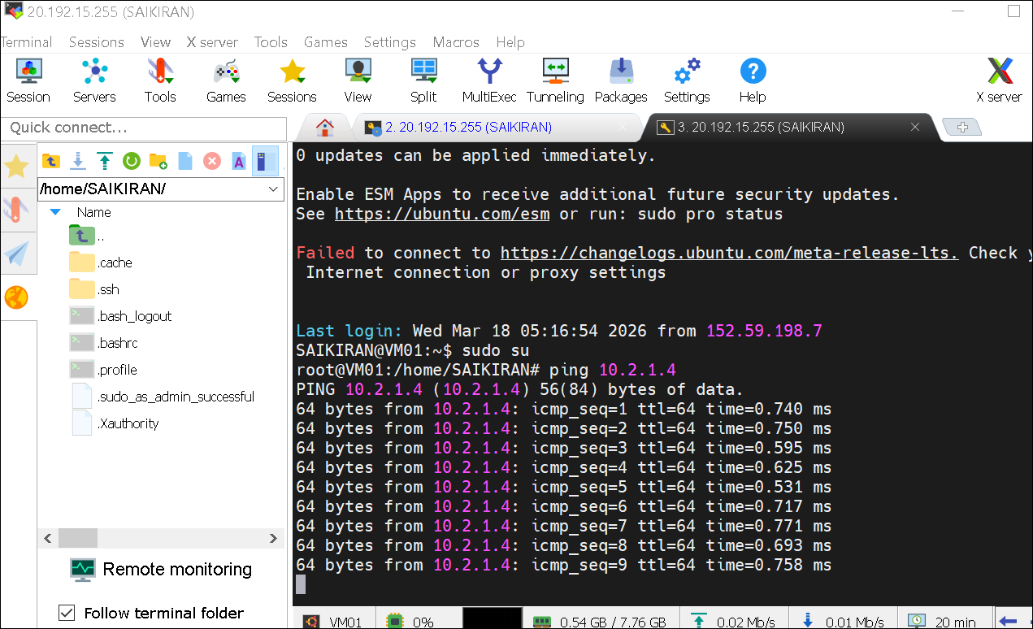
fig(3) successfully connected two Vnets - Regional Vnet Peering

Global VNet Peering :-
  - Connects virtual networks in different Azure regions.
  - Enables private and secure communication across regions
  - Useful for multi-region applications and disaster recovery setups.
→ To implement the Global Vnet Peering, Create two
Virtual Networks with two Virtual Machines in two different regions.

  - Now we need to add peering to the Vnets.
  - log in to the machines and establish the peering using the ping command
Eg:- ping <vm private ip>
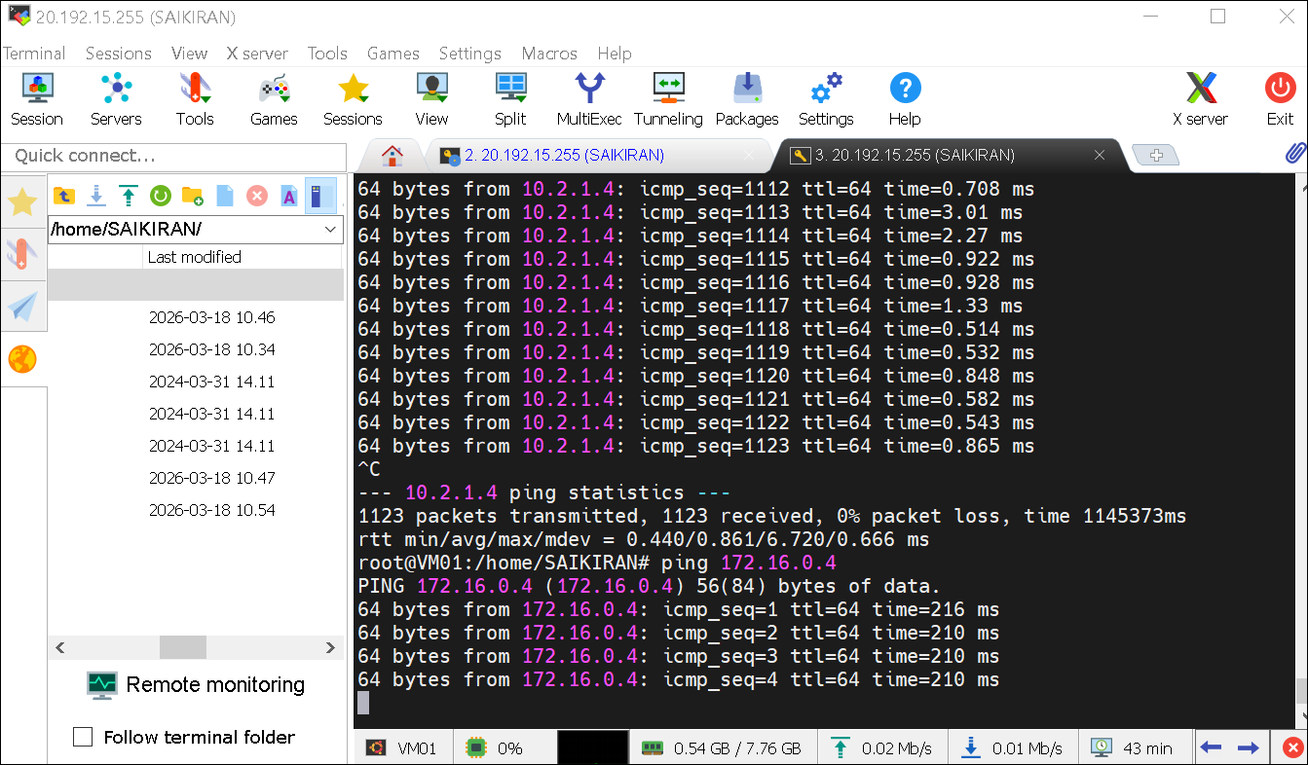

fig(4) Successfully established Global Vnet Peering.

